# **PROJ802 - Individual project**

SUBMITTED BY – ANIRBAN BHATTACHARYYA

SUPERVISOR - **Professor: GALEZ Christine**

YEAR -2020-21

**ABSTRACT**

In our contemporary times, providing electricity using renewal energy is a need for the whole world, for the preservation of the environment on the planet Of course, one of the most effective renewable energy types is wind energy, since our individual project is on the patent research related to the collective project so, I decided to work on the data collection and communication process for the individual project .for the patent research I have used the US PATENT data base (<https://patft.uspto.gov/netahtml/PTO/search-bool.html>) and the key word I have use are respectively LORAWAN , LORA NETWORK .A patent is an exclusive right granted for an invention In other words, a patent is an exclusive right to a product or a process that generally provides a new way of doing something, or offers a new technical solution to a problem To get a patent, technical information about the invention must be disclosed to the public in a patent application The patent owner may give permission to, or license, other parties to use the invention on mutually agreed terms The owner may also sell the right to the invention to someone else, who will then become the new owner of the patent Once a patent expires, the protection ends, and an invention enters the public domain; that is, anyone can commercially exploit the invention without infringing the patent.[1] In this patent the inventor clamed with the help of the Long Rang Wide Area Network they establish roaming between home network and an End-Device roaming in a visited network .The details discussion of the method is tried to explain after wards .

**Table of Contents**

1. INTRODUCTION --------------------------------------------------------------- 4

1.1 DETAILS OF LORAWAN--------------------------------------------------4

2. DETAILS OF THE PATENT -----------------------------------------------------6

2.1 ABSTRACT------------------------------------------------------------------6

2.2 ABBREVIARTIONS ---------------------------------------------------------6

2.3 DESCRIPTION OF THE FIGURE ----------------------------------------7

3. CLAIMED------------------------------------------------------------------------- 9

4.INVENTION-----------------------------------------------------------------------9

5. PRACTICAL----------------------------------------------------------------------- 11

6.CONCLUSION------------------------------------------------------------------- 12

INTRODUCTION

DETAILS OF LORAWAN

LoRa is popularly known as low-power wide area network standard Also called LPWAN This term consists of three parts, 1. low power ,2. wide area And ,3. network .Starting with network The difference between a normal small device and an IOT device is it's capability to connect to the internet .And because we expect millions of them, we need a network to connect all of them This network has to be based on standards because the network itself and the IOT devices will not be built by the same company Best is always an international standard accepted by everybody The next part is wide area .In our project we are using lora node manufacture by DRAGINO LoRa shield v1.4 and THE THINGS NETWORK gateway to our Wi-Fi network which is part of a LAN or local area network .We all know that it's reach is limited to a few meters around our access points .Wide area networks need to bridge much bigger distances This is necessary for IOT devices, because we want to use them everywhere. For the conventional way such as AM(amplitude modulation) radio stations, able to receive AM even in the middle of nowhere Far away from the station and it’s a really wide area But these transmitters were huge Usually they were emitting kilowatts of energy So it seems to be quite easy to bridge big distances using high power But now we come to the first word Low power If we want to work on batteries we do not have lots of power for transmission And here we see the dilemma We want kilometers of reach, but have no power to spend Fortunately physics gives us a third parameter to ease this dilemma a bit It is called bandwidth The physical laws say that if we want to create radio connections for a certain distance, we can either increase transmission power or decrease the bandwidth of the channel But why should we bother about bandwidth? Because bandwidth and maximum capacity of a channel are directly related The smaller the bandwidth, the lower the capacity of our channel. In present days the wireless LANs are capable of transferring millions of characters per second And they are still always too slow to visualize the relation between bandwidth and range where they fit Wi-Fi has a high bandwidth but only a low reach .so to reach 100 meters to few 100 kilometers in rural areas we need a huge power consumption ever the 4G coverage is unable to cover a few kilometers away And we all know that the battery life of our smartphones is not great at all. Because this technology needs quite some power The next technology is Bluetooth this technology runs well on small batteries as we know from many gadgets but unfortunately it reaches only a few meters so all of these technologies do not fulfill the needs of our IOT devices which was low power and wide area ,now what will come LoRa it has its own space long range but because of power limitations also low in reality extremely low bandwidth and this bandwidth is not only limited by the law of physics no it is even more limited by human laws as we will see later on so we know now where LoRa fits to make it very clear it is absolutely not comparable with Wi-Fi and not at all a replacement of this technology it is much closer to the mobile internet standards where also low-power variants .The link budget for LoRa compared with other technologies like LTE or 4G. According to LORA’s inventor Sem tech a link budget of 154 dB which is much higher than the mobile internet with only 130 dB even if the radiated power is much higher than with LoRa but what does this mean is this an important difference , we can find so called radio link budget calculators (https://en.jirous.com/calculation-wifi).

868 megahertz is the frequency used by LoRa in Europe if we ask Google we see that each region uses different frequencies of a LoRa device they all have their band marked on the back of the module .to connect our other devices or applications to these devices here comes the network into play it is called LoRa WAN the LoRa WAN band consists of distributed gateways or concentrators which are connected to the Internet and it consists of an infrastructure which is capable to skylight it the IOT messages to our applications here we have an overview over the whole infrastructure many devices connects to one gateway many gate ways are connected to the broker infrastructure and many applications a real so connected to the same brokers and here we see two different approaches the commercial and the community approach in many places telecom companies started to deploy LoRa networks as with cellular phones you can buy a contract and use this infrastructure you just have to connect your device to the available networks. The Things Network abbreviated TTN .To transfer the messages between the gateways and your application but they need of course many gateways all over the world and because of that they are glad if people like me build such a gateway and deploy it they provide a map of all available gateway sand you can check here if one is close to you if so you can connect your device through the gateway(https://www.thethingsnetwork.org/map)and the TTN network to your application free of charge of course. if we use each device would only use one channel let's say for fifty percent of the time we could already support 16 devices and if each device only would use the channel by one percent of the time we could already support 800 devices just with my gateway and this is exactly the concept this is why I told you before that the bandwidth will be reduced even more and this concept is also in line with the law which allows only a one percent maximum usage of these frequencies by one device so you can divide the 250 bits per second by a factor of 100 which ends up in 2.5 bits per second in the worst case and now we are slower than morse and we are not finished with reducing capacity you remember your walkie-talkies what was the rule there yes only one should speak at one time otherwise nobody got anything and because LoRa uses the same channel for both communication directions this applies here as well to preserve the valuable capacity and because we want to use this network mainly for sensors LoRa favors the direction from the sensors to the Gateway and limit the traffic in the other direction also .I use a Dragino shield and an Arduino Uno , but now let's check if the whole thing works the Arduino should be capable to transfer a message so first let's check in the air yes the spectrum analyzer receives some traffic on frequencies between 868 and 869 megahertz so the sensor device works and the concentrator should get it because we still have lots of link budget left the distance is only a few centimeters and there are no major obstacles between the two devices .[2]

DETAILS OF THE PATENT

Patent No: - us 10,827,345 B1

Date of Patent: Nov. 3,2020

Title – METHORDS AND SYSTEMS FOR LORAWAN TRAFFIC ROUTING AND CONTROL.

Inventors- Ravi Tandon, Huiyue Xu, Himanshu Garg.

ABSTRACT-

A system and method foe routing LORAWAN backend traffic between peer visited and home network server nodes to achieve global roaming in a scalable manner. A LORAWAN Routing and control system is being setup for generate visited network and home network server and generate a proxy signaling and payload data between them .LRCS node help to monitor policy control, billing and roaming agreement with in the LORAWAN roaming network . LRCS node helps to dataflow in between the network and manage the traffic.[3]

In this patent they make 20 claims. claim number 1 is the main claim and claim number 2 to 19 are dependent on the claim 1 and claim number 20 is another individual claim . there are 16 drawings to justifying the claims and to understand how the nodes are connected in their invention and the working procedure ,the explanations of the diagrams are can e fund in the page number 4 as the title of DETAILS DESCRIPTION OF THE INVENTIONS .[3]

ABBREVIARTIONS

The followed abbreviation are used in the patent are mentions below it help to understand the diagram properly .

Lora WAN - Long Range Wide Area Network

LRCS- Lora WAN Routing and Control System/LORAWAN roaming control system

DNS- Domain Name System

MQTT- Message Queuing Telemetry Transport

hNS - home Network Server.

NetID- network ID

FNwkSlntKey- forwarding network session integrity key

SNwkSlntKey - serving network session integrity key

 DNS- Domain name system

IoT- Internet Of Things

fNS/sNS - forwarding/serving Network Server

AS-  Application Server

vNS- virtual Network Server

HTTP- Hypertext Transfer Protocol

EUIs-  Extended User Identifications

NAR- Network Activation Records

NTR -  Network Traffic Records

DTR- Device Traffic Records

ED -End Device

DESCRIPTION OF THE FIGURE

FIG. 1 diagram describing the current Mesh Network Topology used for exchanging Lora WAN Roaming traffic.  
  
FIG. 2 is a diagram describing the topology of Lora WAN Roaming via LRCS node.  
  
FIG. 3 is a diagram describing the internal components of LRCS node.  
  
FIG. 4 is a diagram describing External interfaces of LRCS node.  
  
FIG. 5 is a diagram describing the positioning of LRCS node in a backend Lora WAN Network.  
  
FIG. 6 is a diagram describing LRCS node acting as a Lora WAN Firewall.  
  
FIG. 7 is a diagram describing LRCS node acting as a Lora WAN message aggregator.  
  
FIG. 8 is a diagram describing the call flow for Passive Roaming Activation via LRCS node.  
  
FIG. 9 is a diagram describing the call flow for Handover Roaming Activation via LRCS node.  
  
FIG. 10 is a diagram describing the call flow for Passive Roaming Start via LRCS node.  
  
FIG. 11 is a diagram describing the call flow for Handover Roaming Start/Rejoin request via LRCS node.  
  
FIG. 12 is a diagram describing the call flow for Data exchange via LRCS node.  
  
FIG. 13 is a diagram describing the call flow for managing various Preferred Roaming Partner messages against Non-Preferred Roaming Partner via LRCS node.  
  
FIG. 14 is a diagram describing the call flow for rejecting various messages received from Blacklisted or Non-Roaming Partner Network Server node via LRCS node.  
  
FIG. 15 is a diagram describing the call flow for rejecting various messages originated from Blacklisted or Non-Roaming-Profile End-Device via LRCS node.  
  
FIG. 16 is a diagram describing the call flow for preventing duplicate messages being transmitted from a visited Network Server to multiple home Network Servers.[3]

CLAIMS

This invention provides LORAWAN roaming between the hNS and an ED (end device) roaming to a visited network ,with the help of a LRCS node ,in the LRCS node will help to configure an interface between visited and home network server to route, for conformation, the visited network server configured to send a signaling and payload messages to the IP address of the LORAWAN routing and control system node (LRCS). Receiving the payload messages By the LRCS node to the home server by the visited server after identifying an IP address of a joining server executes the first DNS as query-based first data carried out in the home server as the request message. after getting the response message by join server indicate the end device to authorized to roam in VNS and forward the response message to the visited network server .this message is a profile request message by the LRCS to the visited network server, identifying this by LRCS node. the home network server then executes a second DNS query. by the LRCS node, request message to the home Network Server and receiving, by the LRCS node, a profile-answer message from the home Network Server during an over-the-air roaming activation procedure; and proxying, by the LRCS node, subsequent signaling and payload data messages between the visited Network Server and the Home Network Server, wherein the visited Network Server and the home Network Server transmit the subsequent signaling and payload data messages via the IP address of the LRCS node. [3]

INVENTIONS

The invention is related in the field of telecommunication networks with the help of LORAWAN traffic routing and control. Internet of things devices are essentials and their numbers are increasing ,unlike smart phone and computers IoT devices consumes low power and the data transmission is infrequent the key consideration of invention is low power consumption and capable of transmitting data foe long range . According to Lora WAN specification, each administrator can be arranged with separate wandering strategies, that can permit or prohibit Passive Roaming, Handover Roaming, Passive Roaming based Activation, Handover Roaming based Activation of its individual End-Devices recognized by the Device Extended Unique Identifier (EUI). This prerequisite represents an execution challenge for Lora WAN network administrators since it requires the organization administrators to independently arrange end-gadget based approaches. The invention resolves this issue by keeping global list of roaming arrangements for every Device EUI having a place with Lora WAN organizations.

Considering meandering connection between the visited network recognized by Sender ID and Home organization distinguished by Receiver ID, Lora WAN Roaming Control System (LRCS) can promptly dispose of the traffic from boycotted or course the traffic from whitelisted organizations to address objective organizations. In an epitome, LRCS incorporates a Message Queuing Telemetry Transport (MQTT) representative that gives an interface to peer organizations. As such, the companion organization can straightforwardly buy in to their Network ID or Device EUI themes to get information through a distribute system.

Lora WAN backend traffic dependent on Network Identifier from gadget address dispensed during gadget enactment method. Organization Identifier can be utilized to recognize the Home organization for directing further uplink outlines. In an encapsulation, LRCS is arranged to work like a Lora WAN message aggregator, in this way giving a brought together store to the companion organizations to recover application level messages straightforwardly from LRCS by having a safe interface with their Application Servers. The messages can be put away in an encoded way in the event that home organization would not like to share the encryption keys with LRCS, keeping up the start to finish encryption between End-Device and Application server. [3]

LRCS further empowers for carrying out rating arrangements among different Lora WAN organizations. LRCS can be utilized to choose the favored roaming network, if a similar message is gotten from different wandering accomplices, LRCS can advance just the message got from favored meandering accomplice, while dropping the messages from other wandering accomplices. LRCS can be arranged to help changed strategies for Passive Roaming and Handover Roaming use cases relying on pre-designed arrangement of rules. Besides, LRCS can produce Network Activation Records, Network Traffic Records and Device Traffic Records for charging and examination.[3]

LRCS can add extra routing data to the messages, whenever settled upon by peer LoRaWAN network . This extra data can be added as a feature of seller explicit expansions or another steering boundary that can be characterized as per LoRa partnership endorsement in future. This directing data can be used by different organizations to check that messages are conveyed through a trusted steering specialist situated among Visited and Home Network hubs. [3]

PRACTICAL-

For our collective project the data collection process has been done by the LORAWAN module through the different sensor . the first step of the of experiment is to make connect with module with the gateway has done and I have successfully send a random data in our server .the screen short of the out put in the transmitter end which is end device according to the patent and the receiver end are represented bellow .

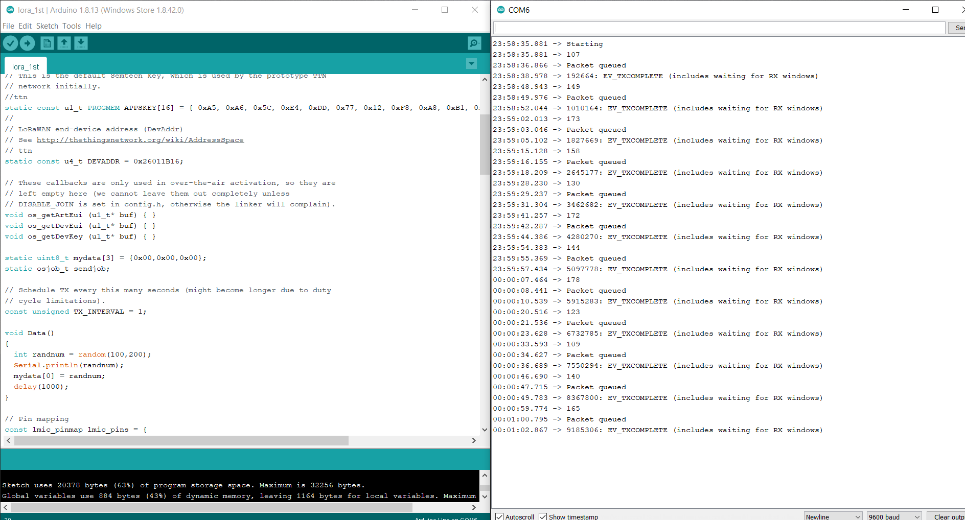

Fig 1. The out put of the Arduino scope the random number has been send through the Lora wan module

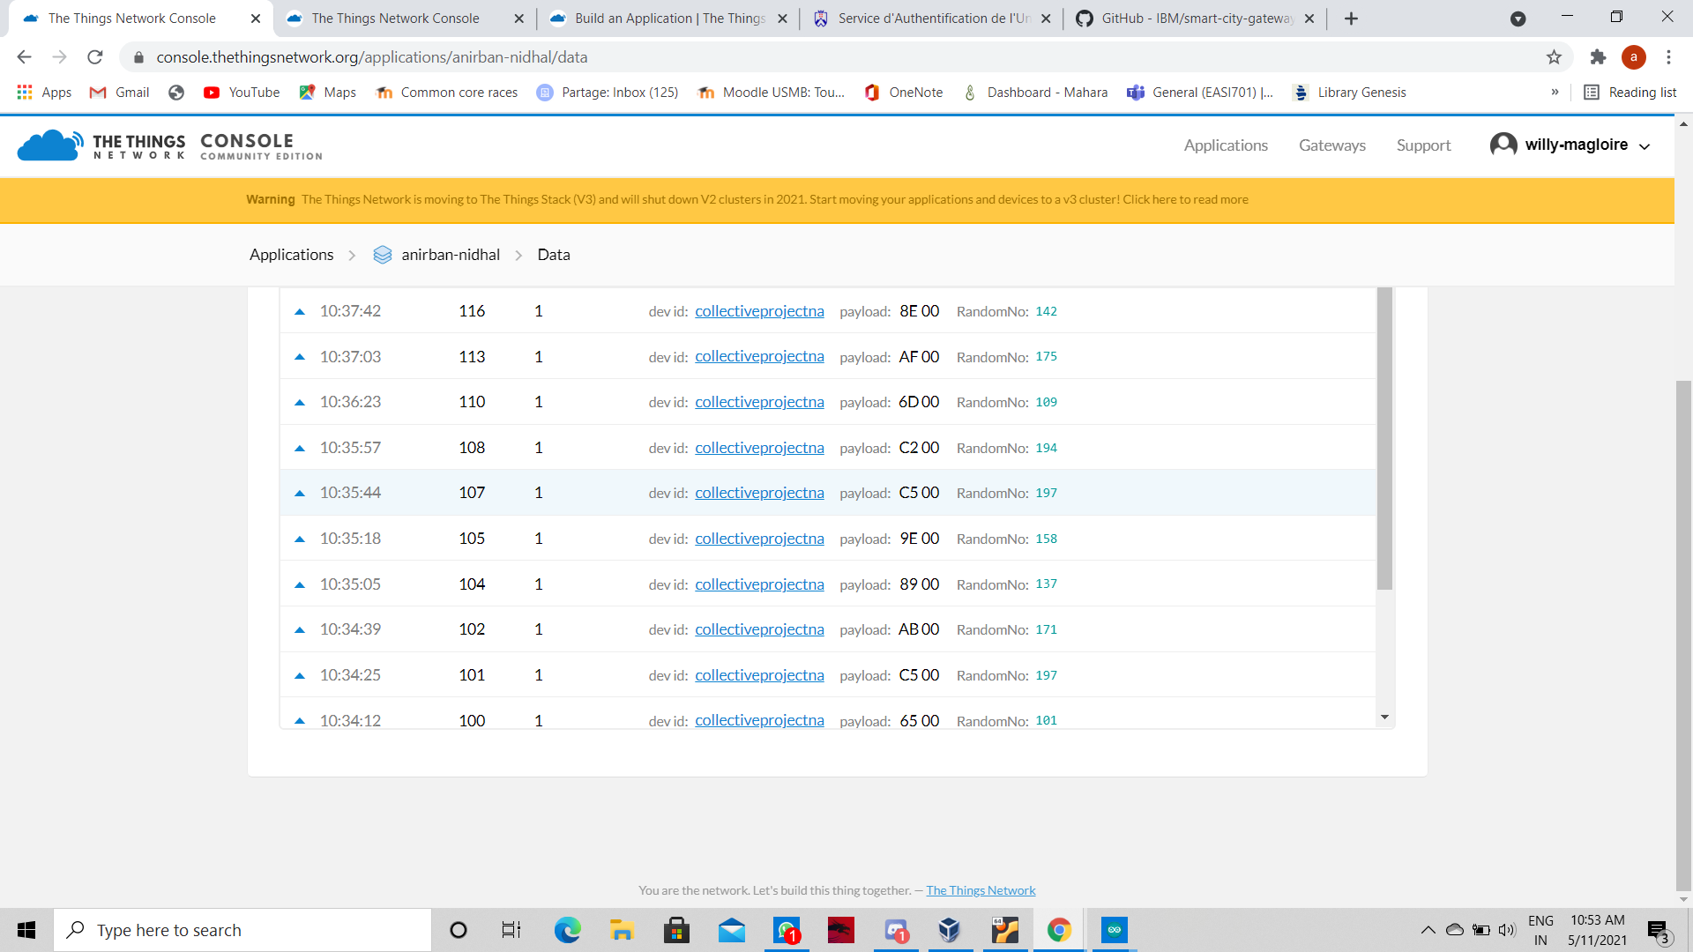

Fig2 the transmitted data from module has been received by gateway

CONCLUSION

There is no doubt to creditability of that patent because it may help us for make data retrieving easy from the sensor through lorawan module .but there are some complication for the connection with gate way of the LORAWAN ,when I was trying to communicate to my home network from long distance such as 4-5 km away it can’t able to communicate and as well as for very short distance the time lapse is near about 20 mins because in the screen short you can see the receiving time of the data and sending time of the data in figure 2. It may be because the network device is very basic .

The invention can be use for the commercial project in the renewable energy from where the data collection from the different sensor are essential and complicated also .

REFERENCES

*[1] Frequently Asked Questions: Patents* (n.d.) Patent Retrieved May 5, 2021, from https://www.wipo.int/patents/en/faq_patents.html

*[2] #112 LoRa / LoRaWAN De-Mystified / Tutorial*. (2017, January 19). [Video]. YouTube. <https://www.youtube.com/watch?v=hMOwbNUpDQA>

[3] “United States Patent: 10827345 - Methods and systems for LoRaWAN traffic routing and control,” 10827345, Nov. 03, 2020 Accessed: May 05, 2021. [Online]. Available: https://patft.uspto.gov/netacgi/nph-Parser?Sect1=PTO1&Sect2=HITOFF&d=PALL&p=1&u=%2Fnetahtml%2FPTO%2Fsrchnum.htm&r=1&f=G&l=50&s1=10,827,345.PN.&OS=PN/10,827,345&RS=PN/10,827,345